MATH Websites/blogs
for teachers

Blogs anglais

http://blog.mrmeyer.com/

http://mathmistakes.org/

http://www.101qs.com/

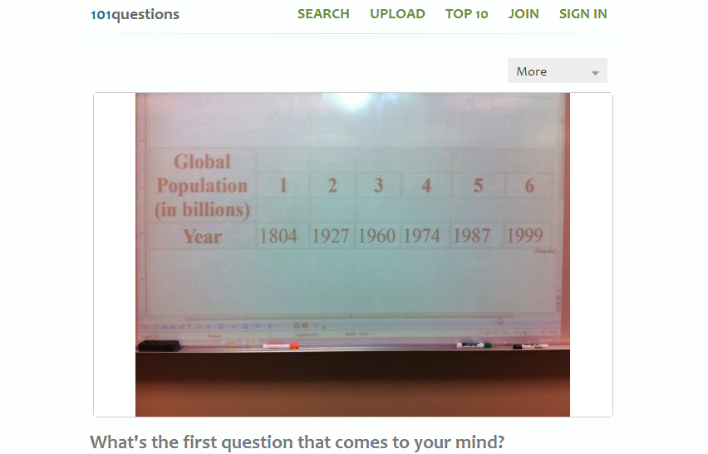

http://www.estimation180.com/

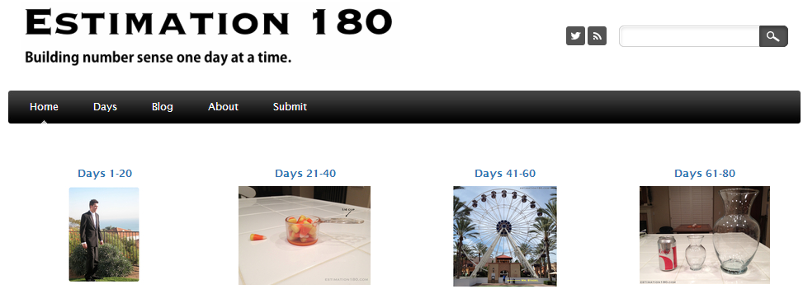

http://graphingstories.com/

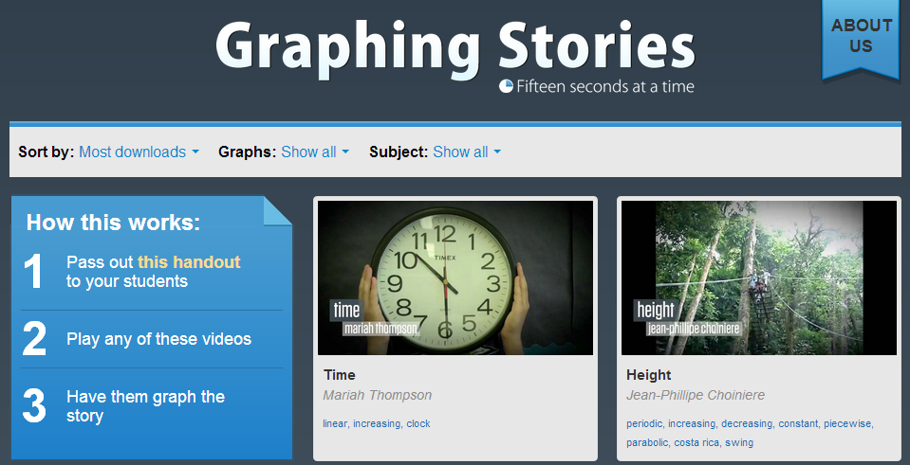

https://www.bigmarker.com/GlobalMathDept#.UOcBrNmraSp

http://www.mathrecap.com/

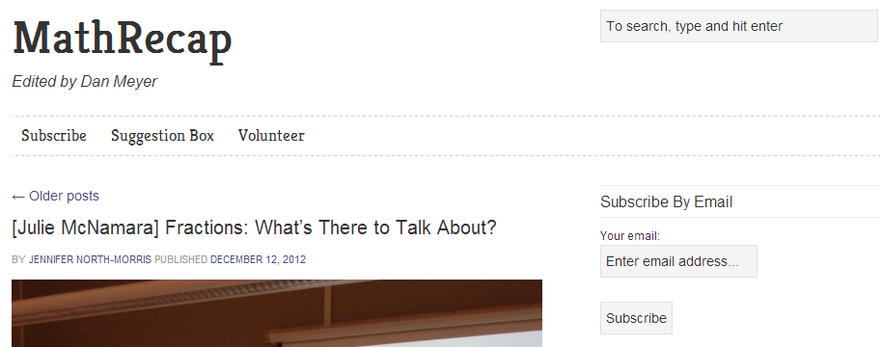

http://www.freetech4teachers.com/

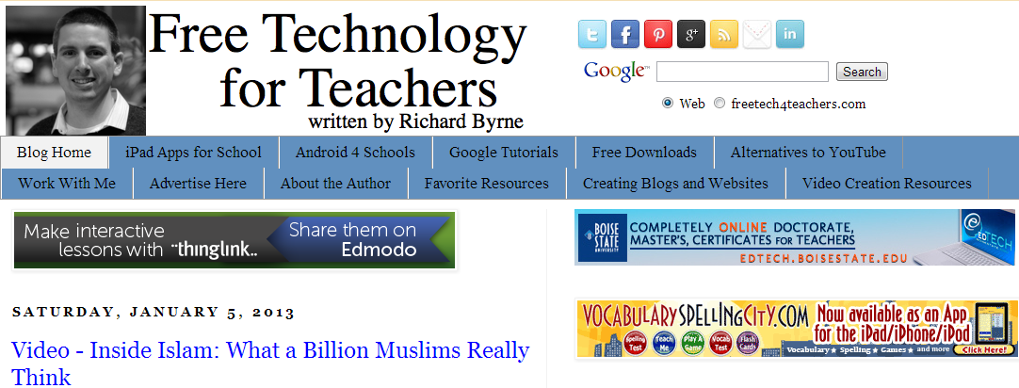

Blogs français

http://ressources-profs.info/?cat=9

Sites anglais

http://activeprompt.herokuapp.com/

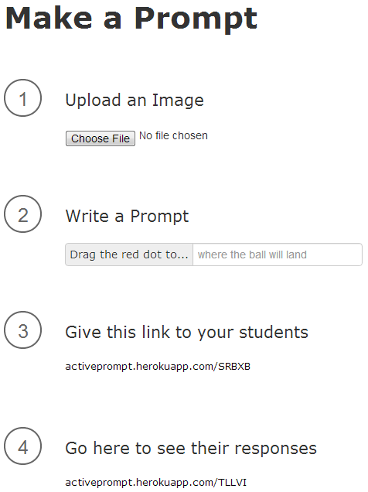

http://www.mathalicious.com/

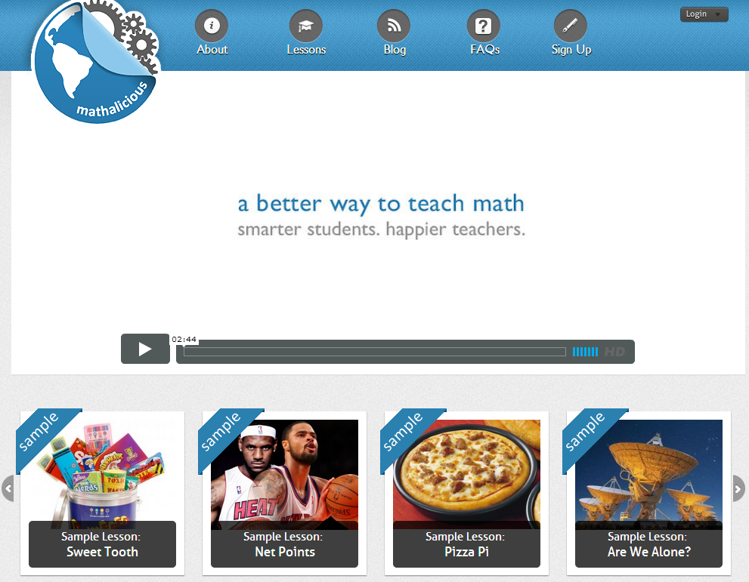

www.desmos.com

http://www.padowan.dk/download/

