**Jeu de logique et raisonnement – Niveau 2**

<http://www.mathfair.com/puzzles.html>

**Neighbourhood sums**

In each of the two boards below, put each of the counters numbered 1, 2, 3, 4, 5 and 6 into a different circle. You score 1 point for a circle if the number printed next to the circle is equal to the sum of the numbers on the counters in all neighbouring circle. (Circles are neighbours if they are connected by a line.) The object is to get as high a total score as possible.

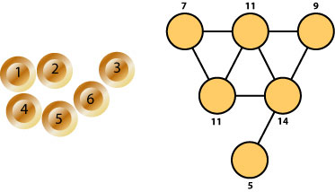

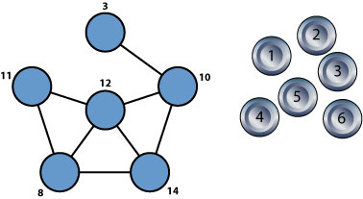

Based on a puzzle in Paul Vaderlind's *The Inquisitive Problem Solver*.

### Eight squares

Place eight 2 × 2 squares on a 4 × 4 square with the smaller squares overlapping one other to produce each of the two configurations below.

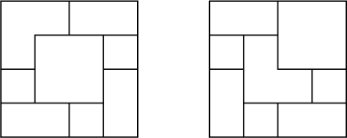

From Kobon Fujimura's The Tokyo Puzzles.

### Soko puzzle I

The board below represents a warehouse containing five numbered boxes. Entering via the doorway, marked by an arrow, you must move the boxes out of the warehouse, not necessarily in numerical order. The thick green regions are solid walls, and you may not pass through them or push boxes through them. You may not jump over the boxes. To push a box, you must get behind it and push it forward into an empty space, along a row or a column. You have to push it completely into the space, not just halfway. You are only allowed to push one box at a time

Try to get as many boxes out of the warehouse as you can.

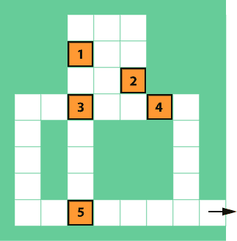

From L.E. Hordern's Sliding Piece Puzzles.

### Soko puzzle II

This Soko puzzle has nine boxes. The instructions are the same as for Soko puzzle I. Try to get as many boxes out of the warehouse as you can.

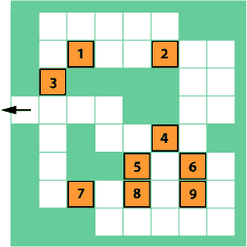

From L.E. Hordern's Sliding Piece Puzzles.

### Abdication

A solitaire game is played on a 3 × 3 board, representing the Capital of a Banana Republic with a 3 × 2 green palace. The king starts on the space I. Five guards, labelled A through E occupy the remaining spaces in the palace. The space O is initially vacant, and the remaining spaces on the board are occupied by two peasants, P and Q.

The King has had enough of it, and plans to quit in the following way.

In each move, if a person is next to an empty space on the board, along a row or a column, then he or she may move into the empty space. The abdication is complete when the King is in space O, with the space I vacant and each guard having returned to his or her starting space. The peasants may switch their positions. Show how this can be done in eighteen moves.

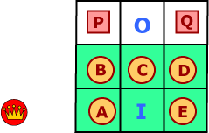

From A. Filipiak's One Hundred Puzzles.

### Regime change

A solitaire game is played on a 4 × 5 board, representing the Capital of a Banana Republic with a 3 × 3 Palace enclosed by double walls. I am the Incumbent Monarch (**I**) and start on the space I. Eight guards occupy the remaining spaces in the Palace. You are the Usurping Rascal (**U**) and start on the space U just outside.

A bloodless coup, with my cooperation, is executed as follows.

In each move, if a person X is between a person Y and an empty space on the board, along a row or a column, then X may be pushed by Y into the empty space, while Y moves into the space just vacated by Y. The change of regime is completed when you are in space I and I am in space U, with each guard returning to his or her starting space. Show how this can be done in ten moves.

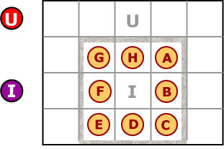

Supplied by Martin Gardner.

**Stairways to heaven**

An archaeologist found a Mayan temple shaped like a hexagonal pyramid with four levels. Each of the six sides had four staircases leading from level to level all the way to the top. The number of steps in the staircases varies, so the archaeologist sent four assistants to count them. The first assistant counted the steps in each of the six staircases leading to the level one, the second counted the steps in the six staircases leading from level one to level two, and so on, and they produced the following report:

|  |  |  |  |  |  |  |
| --- | --- | --- | --- | --- | --- | --- |
| Ground to Level I: | 53, | 50, | 37, | 39, | 42, | 51. |
| Level I to Level II: | 37, | 21, | 30, | 25, | 25, | 35. |
| Level II to Level III: | 29, | 23, | 17, | 19, | 11, | 17. |
| Level III to Level IV: | 11, | 5, | 7, | 3, | 4, | 9. |

The archaeologist recorded the numbers on four hexagonal pieces of paper and pinned them at the center to form the model shown below. He realized that although all the assistants visited the staircases in clockwise order, they did not all start from the same side. The total number of steps altogether is 600, so the archaeologist thought that there must be 100 steps on each side.

Rotate the levels so that as many of the six sides as possible have exactly 100 steps.

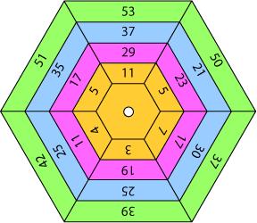

An old puzzle revived by RGee Watkins, Hemet, California.

### Catacombs

An archaeologist found a Mayan dungeon in a shape of a square divided into four quadrants. Each contained a network of interconnected underground pathways. The archaeologist sent four assistants to construct maps of each quadrant. After returning from the expedition, the archaeologist realized that he had failed to label the quadrants. So he put them together as shown below, but he was certain that the pathways do not form just one closed loop but many more.

Put the four maps together so that the pathways form as many closed loops as possible.

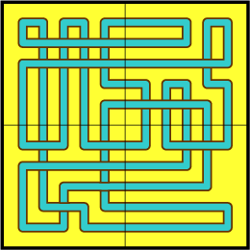

From Nobiyuki Yoshigahara's Puzzles 101