Puzzles style Sudoku

<http://www.mathfair.com/sudokutype.html>

### Latin Squares

The solution to the preceding puzzle is a Latin square. The pictures on the left are Latin squares. You've probably noticed that they share something similar. In the 3 by 3 grid, each cell contains one of 3 different tokens - red, blue, or yellow. Each row and each column contains all three types of tokens.

In the 4 by 4 grid, each cell contains one of 4 different symbols. Each row and each column contains all four different symbols. There are also 5 by 5 Latin squares, 6 by 6 Latin squares, and so on. A typical Sudoku puzzle is a special type of a 9 by 9 Latin square.

**Cats, cows, and pigs**

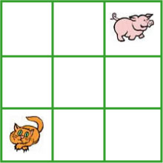

A farmer has nine animal pens arranged in three rows of three. Each pen must contain a cat, a pig, or a cow. There is already a pig and a cat in two of the pens. The farmer wants you to fill the remaining pens so that no row or column contains two of the same animals.

### Apples and bananas I

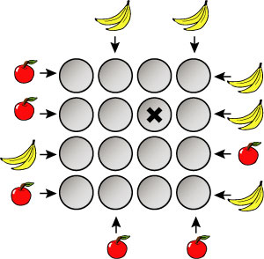

There are sixteen plates laid out in rows and columns in a square pattern on the table. Each row and column has one plate containing an apple, one plate with a banana, and two empty plates. In the picture above, the fruit outside the grid of plates tell what fruit is closest to you in that row or column when you look in the direction of the arrow. The plate with an **X** is empty. Find out what plates are empty and determine what type of fruit is on each nonempty plate.

### Apples and bananas II

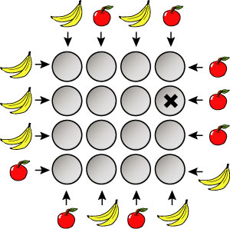

There are sixteen plates laid out in rows and columns in a square pattern on the table. Each row and column has one plate containing an apple, one plate with a banana, and two empty plates. In the picture above, the fruit outside the grid of plates tell what fruit is closest to you in that row or column when you look in the direction of the arrow. The plate marked with an **X** is empty. Find out what plates are empty and determine what type of fruit is on each nonempty plate.

### Apples, bananas, and cherries

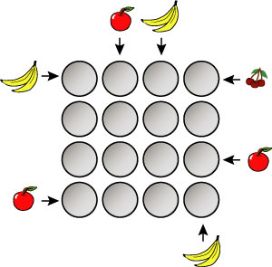

There are sixteen plates laid out in rows and columns in a square pattern on the table. Each row and column has one empty plate, one plate containing an apple, one plate with a banana, and one plate with cherries. No plate contains more than one type of fruit. In the picture above, the fruit outside the grid of plates tell what fruit is closest to you in that row or column when you look in the direction of the arrow. Find out what plates are empty and determine what type of fruit is on each nonempty plate.

### Four skyscraper puzzles http://www.mathfair.com/images/skyscrapers.gif

In a town there are 16 skyscrapers on a four-by-four grid. In each row or column, the buildings range in height from 1 story to 4 stories.



If you stand outside the grid and look down a row (or column), a skyscraper in that row will be hidden from view if there is a taller one in front of it. In the picture on the left, you could see two skyscrapers if you were standing at one end of the row and and three skyscrapers if you were standing at the other end.

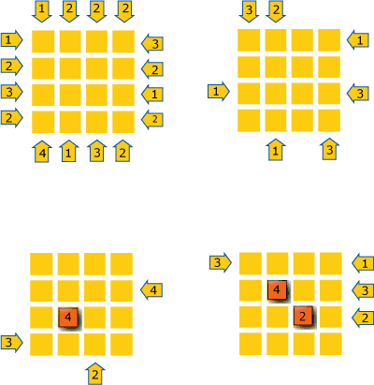

The four pictures above represent four different towns, the numbers outside the grids tell how many skyscrapers you can see when you look in that direction down the row or column.

For each of these four puzzles, you are asked to determine the height (in stories) of each of the skyscrapers. In two of the puzzles, the height of some of the skyscrapers is known.

### Colourful cats and pigs I

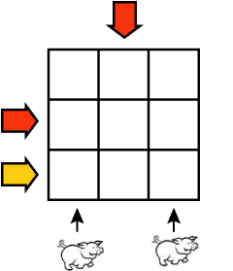

A farmer has nine animal pens arranged in three rows of three. Into these pens, a farmer has placed six animals — a red cat, a yellow cat, and a blue cat, and a red pig, a yellow pig, and a blue pig. Each row and column has one empty pen, one pen with a cat, and one pen with a pig that is a different colour than the cat.

In the picture above, there are arrows pointing to some rows and columns that tell you something about the animal that is closest to you in that row or column. For example, the red arrow at the top tells you that the animal closest to you from that direction is red. The arrow and pig at the bottom right tells you that the animal closest to you from that direction is a pig.

Can you figure out where the six animals are?

### Colourful cats and pigs II

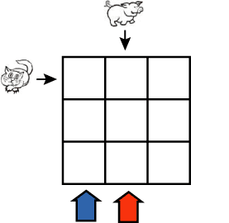

This is the same as the puzzle above, except that the animals have been moved to different pens.

### Four colours

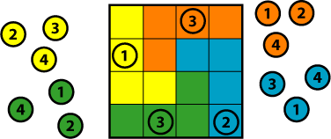

Write the numbers from 1 to 4 on four sets of different coloured chips. Make a 4 by 4 board and colour it, using the pattern above, with the same colours as the chips.

Put the chips on the board so that each row and column contains all four numbers. You have to put each chip on a square of the same colour. The first four chips have to be placed as shown.

### The wizard's hats

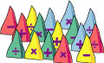

A lady wizard has sixteen different hats. Four hats are yellow, four are red, four are blue, and four are green. Four hats have a plus sign on them, four have a minus sign, four have a multiplication sign, and four have a division sign (she's a math wizard). No two hats of the same colour have the same sign on them.

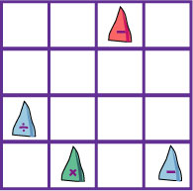

She has a special packing crate with sixteen compartments to store the hats. The compartments form four rows and four columns. When she packs the crate she puts one hat in each compartment in such a way that every row and column has four different coloured hats and four different arithmetic signs.

She has started to put the hats in the crate. The picture shows where she has put four of the hats. Can you finish packing the crate for her?