Nom : ____________________________
Mathématiques 10-4


/50

Prix unitaire
Examen de module

Question # 1. /5
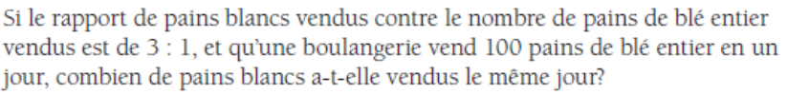

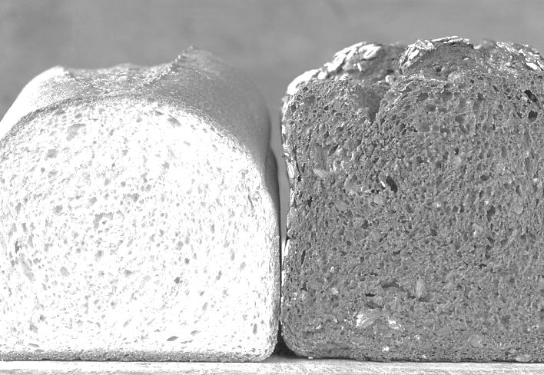

Question # 2. /5
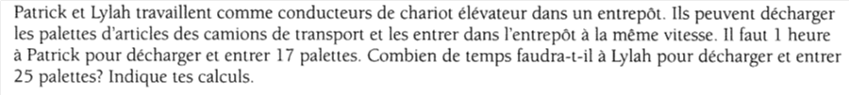



Question # 3. /10
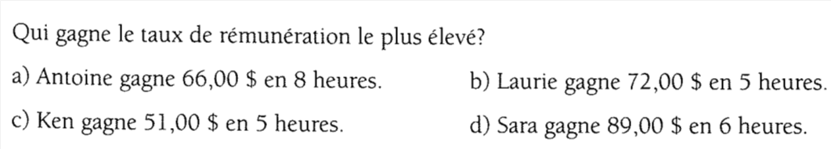
- Antoine | - Laurie
- Ken | - Sara
Question # 4. /5

Question # 5. /5

Question # 6. /10
Magasin A | Magasin B | Magasin C

Questions # 7. /10
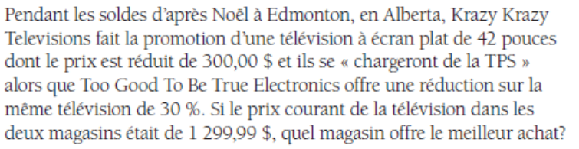
Krazy Krazy Televisons | Too Good To Be True Electronics

