Engaging Learning for Early Childhood
Professionals

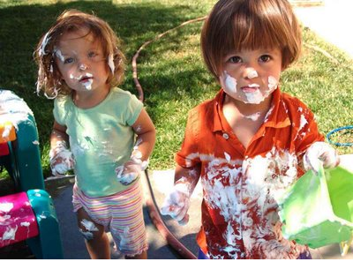 | 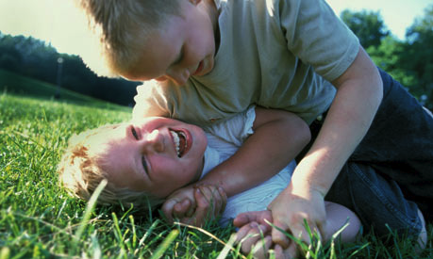
 | 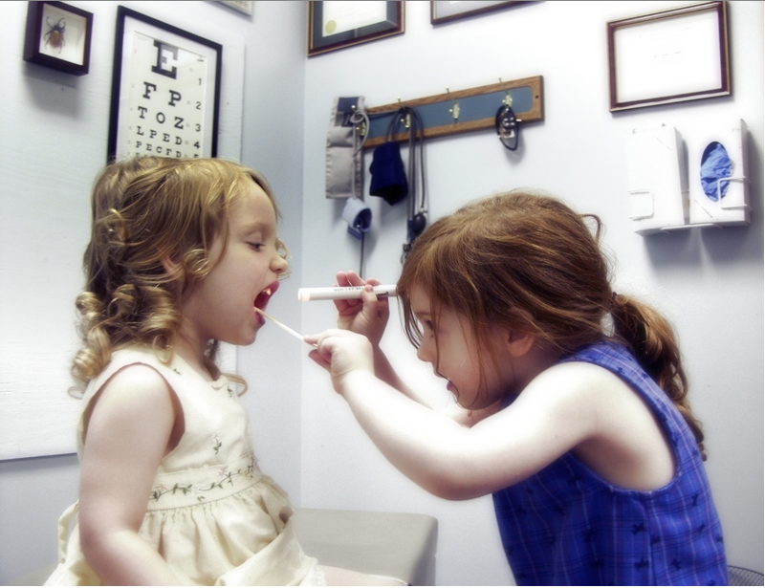

Engaging Learning for Early Childhood Professionals Agenda Day 3
Focus: Looking at practice
Outcomes:
- Analyze and synthesize practices to determine research connections.
- Effectively communicating practice and research to a parent community.
Time | Topic | Process
9:00- 9:15 | Welcome  Overview of the day  Set-up group 1- (those that focused on changes to physical space) | Group one (physical space) displays artifacts of practice that they brought with them (facilitator choose 1 example to present to other groups via VC)
9:15- 10:00 | View group 1’s artifacts of practice & discuss. Prepare jot notes (p.3) to aid discussion. | Participants view, make jot notes and discuss artifacts from their site.
10:00- 10:15 | VC – Examine 1 example of physical space from each site | Present 1 example from each of the 4 sites through VC (Calgary, Bonnyville, Edmonton, Grande Prairie)
10:15- 10:30 | Health Break  Set-up group 2- (those that focused on learning design) | Group two (learning design) displays artifacts of practice that they brought with them. (choose 1 example to present via VC)
10:30- 11:30 | View group 2 artifacts of practice and discuss. Prepare jot notes (p.4) for discussion. | Participants view, make jot notes and discuss artifacts from their site.
11:30-12:00 | VC – Examine 1 example of learning design from each site | Present 1 example from each of the 4 sites through VC (Calgary, Bonnyville, Edmonton, Grande Prairie)
12:00 -12:45 | Lunch  Set-up group 3- (those that focused on assessment) | Group three (assessment) displays artifacts of practice that they brought with them. (choose 1 example to present via VC)
12:45- 1:30 | View group 3 artifacts of practice and discuss. Prepare jot notes (p.5) for discussion. | Participants view, make jot notes and discuss artifacts from their site.
1:30 – 2:00 | VC – Examine 1 example of assessment from each site | Present 1 example from each of the 4 sites through VC (Calgary, Bonnyville, Edmonton, Grande Prairie)
2:00 – 2:30 | Communicating with parents | Table group work  - Generate ideas about how to effectively engage parents in the ongoing work of the classroom and their child’s learning
2:30 – 2:45 | Debrief communication ideas  Blogs and online communication | Presentation and discussion  Examples of a class blog and online video displayed on 3P class website
2:45 – 3:00 | Closing Remarks and Next Steps  Workshop Series Website http://www.galileo.org/pl/earlylearning/  University of Calgary ECE graduate course  http://www.ucalgary.ca/gpe/content/early-childhood-education  Conference  Journey of possibilities: Reggio Inspirations in Elementary Contexts  April 28 – 30 Rozsa Centre ~ University of Calgary

Physical Spaces in Support of Meaningful Play-based Learning

As you view artifacts of practice related to the physical space, consider how the changes to the physical environment and availability of materials support play-based learning.

Consider spaces and availability of materials for:

body and movement play

imaginative pretend play

object play

social play

creative play

Learning Design
As you view the artifacts of practice, consider the following.
Effective early learning environments:
- Enable children to initiate learning and share ideas
- Foster executive function (self-regulation of social, emotional and cognitive behaviour)
- Provide for different groupings of children (individual, partners, small group, whole group etc.)
- Invite children to explore or use interesting or authentic materials
- Encourage children to make connections, make comparisons, offer an opinion, and imagine
- Provide open-ended activities that foster imagination
- Provide authentic, real-world opportunities for thinking, working and “hard fun”
- Provide for choice and exploration both inside and outside the room
- Provide rich narrative and language opportunities where children imagine and talk about personally meaningful experiences
- Foster a sense of belonging and creates opportunities to build social relationships
- Foster a love of music, the arts and creative expression
- Empower children i.e. is there a balance of child talk and teacher talk? Are children included in the decision-making?

Assessment Practices
As you view the artifacts of assessment, consider the following:
- To what extent does the assessment reflect what the teacher said was important for children to learn?
- How well does the assessment information capture the breadth and complexity of children's learning and development?
- How is assessment information about children's learning used to guide their next learning steps? (i.e. the notion of “serve and return” and making learning “visible” to improve it)
What to look for in early learning settings:
- Children making their own judgments about their achievements, developing their sense of what counts as good work for themselves as learners.
- Children self-regulating, that is, self-assessing and giving themselves instructions about what to do. This includes seeing mistakes as part of the process of learning.
- Children deciding what should be recorded in their assessment portfolios.
- Occasions when the resources being used by children provides feedback about their performance (for example, a completed puzzle).
- Evidence of "some inner sense of satisfaction" as the "touchstone" of quality. (Teachers who know children well can often identify that evidence.)
- Children using materials to provide reference points against which to assess their achievements.
- Children using earlier work in their own assessment portfolios to judge current success or progress.
- Children revisiting their assessment portfolios, with or without the teacher.
- Children correcting their assessment portfolios.

Communicating with Parents

Ways to effectively engage parents in the ongoing work of the classroom and their child’s learning.

