**Jeu de logique et raisonnement – Niveau 1**

<http://www.mathfair.com/puzzles.html>

**Spoke sums**

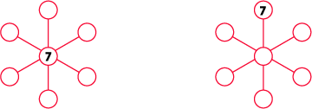

Place the numbers from 1 to 6 in the circles so that every three numbers in a straight line have the same sum.

### Number wheel

In the figure above, numbers have been placed in the circles. For every pair of neighbouring numbers, the sum of the pair equals the sum of the opposite numbers.

The problem is to place the digits 1 through 6 into the circles using each number as few times as possible. In the picture on the left, we used the number 3 twice.

In each of the figures below the 1 and 5 are already in place. In each case, finish the puzzle by putting the numbers 2, 3, 4 and 6 in the proper places.

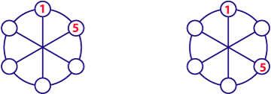

(This is a simpler version of Order the numbers from The Moscow Puzzles by Boris Kordemsky)

### Buggy jump

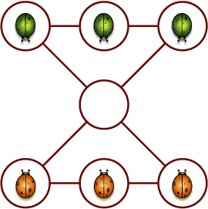

Three red bugs and three green bugs are playing a game on the board shown above. The red bugs and green bugs have to change places. They are allowed to do the following:

A bug may move from its spot along a line to an empty space as long as it doesn't pass over another bug.

A bug that is in one of the corner spots may jump over another bug of a different colour provided it jumps in a straight line and lands in an empty space.

A bug cannot jump over a bug of the same colour.

### Pyramid

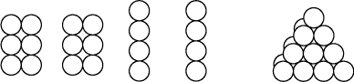

Using 20 styrofoam balls, glue them together to form two 1 by 4 pieces and two 2 by 3 pieces as shown above on the left. The problem is to stack them in such a way that they form a triangular pyramid, that is, a tetrahedron as on the right.

(From one of Brian Bolt's books.)

### Nine men in a trench

http://www.mathfair.com/images/trench.gif

Move the red marker from the right end to the left end. You can move markers into the spaces, but cannot double them up. Nor can you jump a marker over another.

### Star jump

The figure above should be redrawn so that the circles are each big enough to hold a penny.

Take four pennies. The problem is to put a penny in each of the shaded circles. However, there's a catch. Here's the rules that you have to follow.

To begin, take a penny. Put your finger on a circle. There is an arrow that points from that circle to another circle, and that's where you have to put the first penny.

Continue in this way, each time putting your finger on an **empty circle** and placing a penny where the arrow points to.

### Circle jump This is a variation of the Star Jump problem.

Redraw the figure so that each of the seven circles is big enough to hold a penny. Take six pennies. The problem is to put a penny in each of the shaded circles. However, there's a catch. Here's the rules that you have to follow.

Starting with any circle, count clockwise three circles and place the first penny there. Continue in this way, each time beginning at an empty circle and counting clockwise three circles and placing a penny there.

(From The Moscow Puzzles by Boris Kordemsky, where it was called matches and coins.)

### Circle jump II This is a another variation of the Star Jump problem.

Enlarge the figure so that each of the eight circles is big enough to hold a penny. Take seven pennies. The problem is to put a penny in each of the seven shaded circles. However, there's a catch. Here's the rules that you have to follow.

Starting with any circle except the white one, count clockwise one circle, and place the first penny there. Then, starting at any empty circle (including the white one), count clockwise two circles and place the second penny there. Then, beginning at one of the remaining empty circles, count clockwise three circles and place the third penny there. Continue in this way for four, then five, then six, and finally seven circles.

### Four cottages

Below is a map of a circular road. The distance between the dots is 1 kilometre. There are two houses on the road, and two more house are going to built. The local council has asked you where they should be put so that given any of the distances from 1 to 12, there are two houses that are that far apart. Of course, the two houses that are there are separated by 1 kilometre or 12 kilometres, depending upon what direction you travel, so you only have to concern yourself with the distances of 2, 3, 4, 5, 6, 7, 8, 9, 10, and 11.

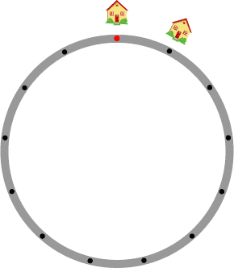

This puzzle is inspired by The six cottages from Dudeney's 536 puzzles and curious problems.

### Free the animals

In the picture below, there are sixteen square cages arranged in 4 rows of 4. Each cage contains 1, 2, 3, or 4 captured animals, represented by red chips. Your task is to free all of the animals, but there are rules that have to be followed: you must release two animals at a time, but they have to be in different cages, and the two cages have to have a common side.

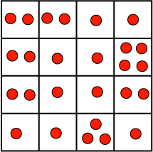

### Sam's house

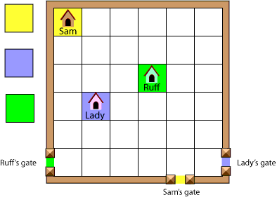

Sam, Ruff, and Lady are three dogs whose houses are inside a yard with brick walls and square paving stones. To leave the yard, each dog has to go through its own special gate shown in the picture above. Your problem is to design paths that the dogs can follow to get to their own gates. Sam's path should be coloured yellow, Ruff's should be colored green, and Lady's should be blue.

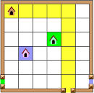

The paths are made by colouring the paving stones. Each path has to be made of coloured stones that are connected edge to edge (not corner to corner), and of course the paths are not allowed to cross. In the picture on the left, a path for Sam has been made, but you can see that there is a problem: there is no way to make Lady's blue path reach her gate without crossing Sam's path.

Instead of colouring, you can save some time by cutting out about twenty yellow squares, twenty blue squares, and twenty green squares and placing them on the paving stones.

This is a variation of The Quarrelsome Neighbors by Sam Loyd