Autres puzzles

http://www.mathfair.com/puzzles3.html

Catch the thief
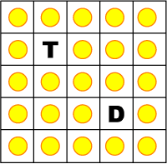
There is a thief T and a detective D, and a whole lot of stolen money (represented by the 23 gold coins). To catch the thief, the detective can move from one square to a square next to it either vertically, horizontally, or diagonally. To catch the thief, he has to end up on the same square as the thief. The thief does not move.
There is a reward for the detective. Each time the detective enters a square, if there is a coin there, the detective picks it up, but if there is no coin there the detective has to put a coin back down. As a reward, the detective gets to keep the money that he has collected.
See how large a reward you can get.

Catch the crooked thief
There is a thief and a detective as shown in the previous puzzle. To catch the thief, the detective can move from one square to a square next to it either vertically, horizontally, or diagonally. However, this time the detective must change his direction every time he moves. For example, if the detective has just moved diagonally north-east, then his next move cannot be diagonally north-east.
As before, the thief does not move, and the detective catches the thief by ending up on the same square as the thief. Again, there is a reward for the detective. Each time the detective enters a square, if there is a coin there, the detective picks it up, but if there is no coin there the detective has to put a coin back down. As a reward, the detective gets to keep the money that he has collected.
See how large a reward you can get.

Cherry glasses
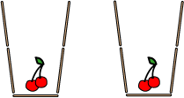
The toothpics in the picture form two glasses. Can you get the cherries outside of the glasses by rearranging four sticks. You're not permitted to move the cherries.
(Found at Interactive Fun Puzzles. There is a nice collection of toothpick puzzles at puzzles.com)

Coin jumping I
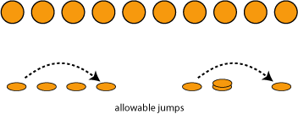
Put 10 coins in a row from left to right.
By jumping over other coins, we want to make five stacks of two coins. The rules are as follows:
You may pick up any coin and jump over two adjacent coins and place it on top of the third coin. You may jump in either direction.
The coin that you pick up cannot come from a stack of two coins.

Coin jumping II
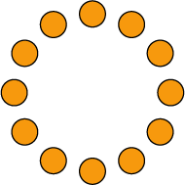
Place twelve coins in a circle. By jumping over other coins, we want to make six stacks of two coins. The rules are as the same as above. You may jump either clockwise or counter-clockwise.

Evensies
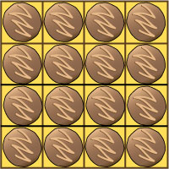
Erica doesn't like odd numbers, so the box of chocolates shown above meets with her approval. The problem is that she has to remove six chocolates from the box in such a way that she leaves an even number of chocolates in each row and each column.
Make a 4 by 4 grid, and using pennies or other tokens as chocolates, show how she can do this. There is more than one solution.
(From Boris Kordemsky's Moscow Puzzles.)

The 22 game
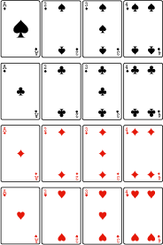
Place sixteen playing cards as shown.
Two players alternately turn down a card and add it to the common total. The winner is the person who makes the total 22 or who forces the other player to go beyond 22.
For example, Alice turns down a 3, Bill turns down a 4 making the total 7. Then Alice turns down a 1, making the total 8, and Bill turns down another 4, making the total 12. Alice turns down a 3 (total 15). Bill turns down a 3 (total 18) and Alice wins by turning down a 4.
Another example: Alice and Bill turn down 1 and 1, then 1 and 1, then 2 and 2, then 3 and 3, then 3 and 4. The common total is 21, and so Bill wins because there are no 1's left and what ever Alice turns down will bring the total to more than 22.
Remarks: This is a puzzle by Dudeney. This was a very popular puzzle at one math fair. Rather than playing against the visitors, the presenters encouraged visitors to play against each other. In this way, the presenters were able to help the visitors without causing the visitors to feel defeated.

Switch positions
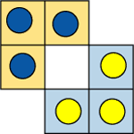
The picture shows a 3 by 3 board with two missing corners. There are 3 blue chips on the yellow part of the board and 3 yellow chips on the blue part of the board. The problem is to put the blue chips on the blue part and the yellow chips on the yellow part. The rules are as follows:
You can move a chip from one square to a square next to it if the square is empty.
You can jump a chip over a different coloured chip next to it as long as you land in an empty space.
You cannot move or jump diagonally.
(This is a simpler variation of a puzzle presented by both Loyd and Dudeney).

Spellbound frogs
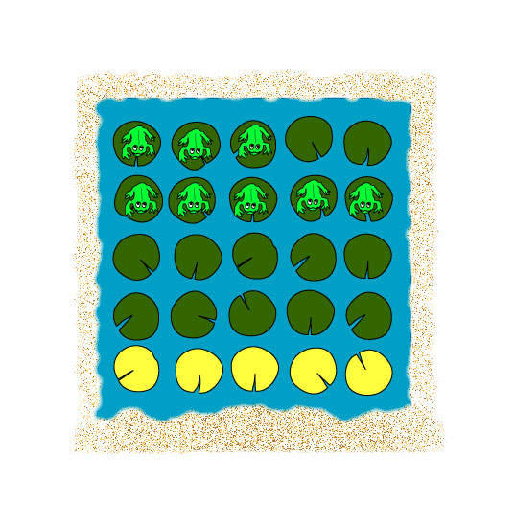
Eight frogs sit on lily pads in a square pond.
A nasty wizard has cast a spell of timidity over the frogs. The spell works like this: as soon as something jumps over a frog, it will dive into the water and stay at the bottom of the pond until the spell is broken.
To break the spell, one of the frogs must hop onto one of the yellow magic lily pads. As soon as one frog lands on a magic lily pad, all frogs are freed from the spell. It's your task to figure out how the frogs can do this when they start from the positions shown in the picture.
However, there's a complication: frogs are only allowed to jump over another frog next to it and land on the next lily pad, and the frogs can only jump horizontally and vertically, not diagonally. A frog cannot jump over an empty lily pad, and two frogs cannot share the same lily pad.

The Die Hard jugs
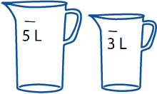
In the film Die Hard With A Vengeance, the characters John McClane and Zeus Carver open a briefcase only to discover that in doing so they have armed a powerful bomb. It will explode in a matter of minutes unless they can disarm it. Inside the briefcase there is a scale. They have at their disposal two jugs — one holds exactly 5 litres and the other holds exactly 3 litres. To disarm the bomb, they have to fill the 5 litre jug with exactly four litres of water and place it on the scale. A few grams too much or too little will detonate the bomb. The water can be obtained from a nearby fountain.
How can they disarm the bomb?
(This is a classic puzzle, and variations can be found in Loyd's and Dudeney's puzzle collections. By the way, the film never actually showed how McClane and Carver solved the puzzle.)

