Activité NRICH
1er cycle du secondaire

Arithmagones additifs

Définition

Un arithmagone est un polygone avec des numéros à ses sommets (les cercles) qui déterminent les nombres écrits sur ses bords (les boîtes) par l’intermédiaire de l’addition.

Question : Solution :

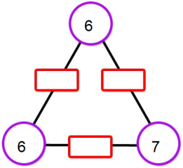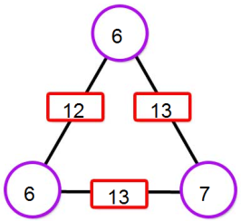

Variante

Si on donne les nombres dans les boîtes et on demande de trouver les nombres dans les cercles, l’activité devient plus riche.

Question : Solution :

Activité

Les élèves complètes les arithmagones additifs donnés à la fiche reproductible 1, 2 et 3.

Variante

Les élèves créent des arithmagones additifs. Voir Fiche reproductible 4.
Leurs amis complètent les arithmagones de leurs amis.

Enrichissement

Les élèves créent des artihmagones multiplicatifs. Voir Fiche reproductible 5.
Si c’est possible, les amis essaient de compléter les créations des autres.

Source : http://nrich.maths.org/2670

7e année
Le nombre
Résultat d’apprentissage général : Développer le sens du nombre.
Résultat d’apprentissage spécifique
RAS 6. Démontrer une compréhension de l’addition et de la soustraction de nombres entiers, de façon
concrète, imagée et symbolique.
[C, L, R, RP, V]

Mathématiques M-9 – Programme d’études de l’Alberta
©Alberta Education, Canada, 2007

Fiche reproductible 1 -

Arithmagones additifs
avec entiers négatifs

1. 2.
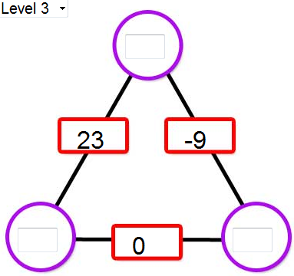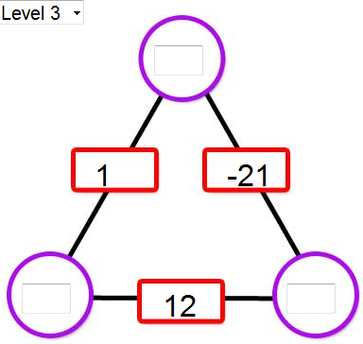

3. 4.
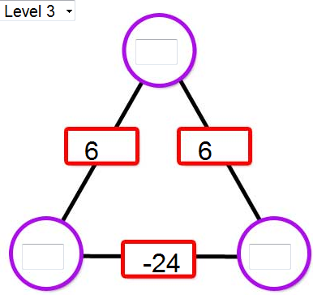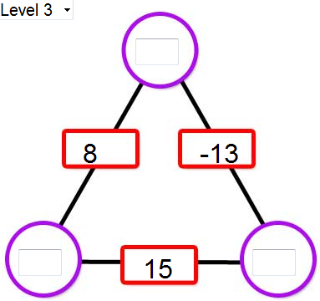

5. 6.
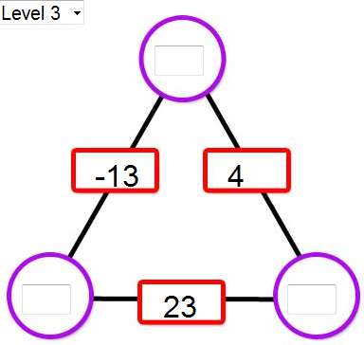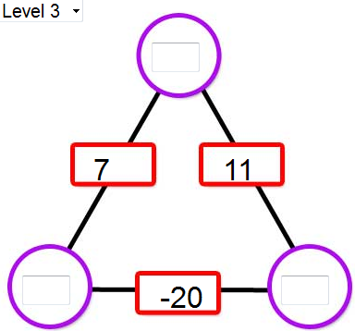

Fiche reproductible 2 -

Arithmagones additifs
avec entiers négatifs

1. 2.
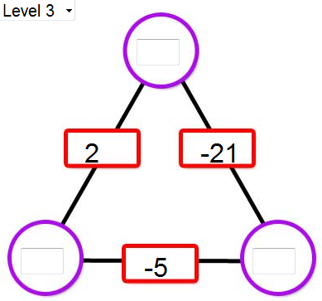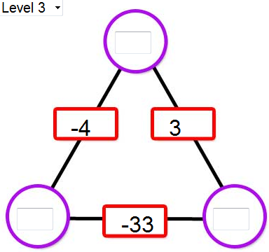

3. 4.
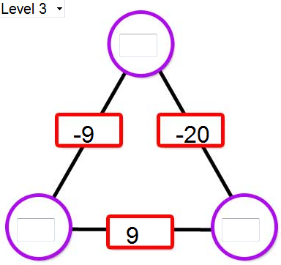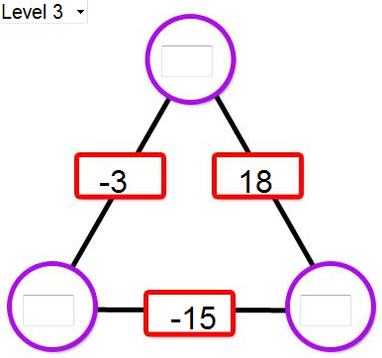

5. 6.
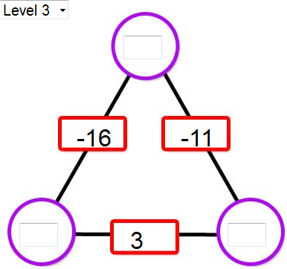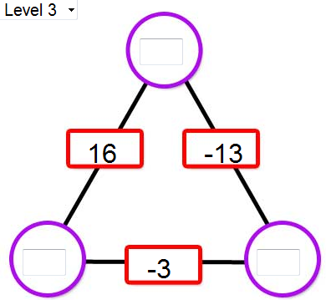

Fiche reproductible 3 -

Arithmagones additifs
avec entiers négatifs

1. 2.
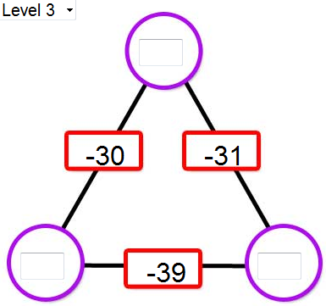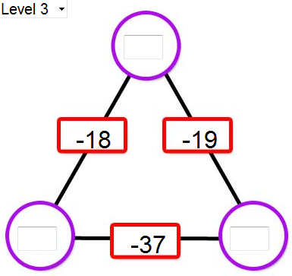

3. 4.
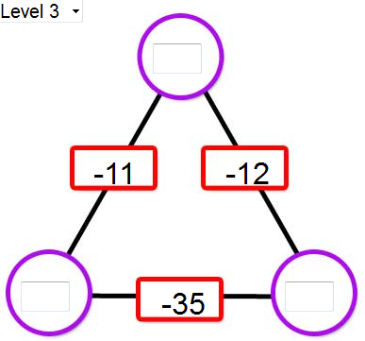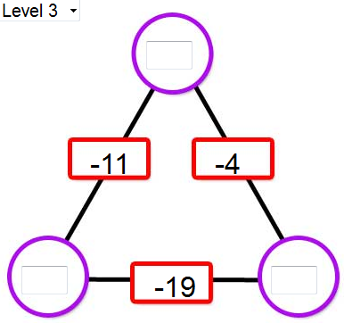

5. 6.
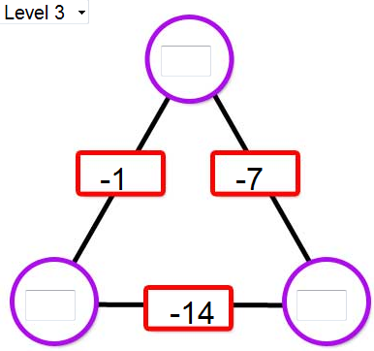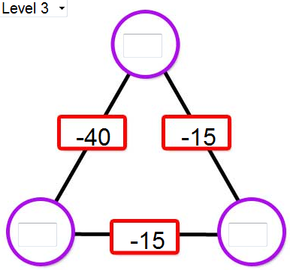

Fiche reproductible 4 -

Arithmagones additifs
Création

1. 2.

3. 4.

5. 6.

Fiche reproductible 5 -

Arithmagones multiplicatifs
Création

1. 2.

3. 4.

5. 6.

Solutions
Esther did some wonderful "detective work" and made a number of very useful observations:
1) The totals in the squares are double the totals in the circles. I think this is because each circle number is used twice to solve the puzzle.
2) If the numbers in the squares are all even, the numbers in the circles are either all odd or all even.
If the numbers in the squares are all odd, I cannot solve the puzzle with whole numbers. This is because an even number minus an odd number equals an odd number.
If you have two odd and one even in the squares then the numbers in the circles are either two odd and one even or two even and one odd.
However, if you have two even and one odd number in the squares you cannot solve the puzzle using whole numbers.
3) If you draw the lines of symmetry through a circle and the opposite square, the difference in the numbers in the squares on either side equals the difference in the numbers in the circles on either side.
Also the sum of the numbers on each line of symmetry is the same. This also works for decimals and negative numbers.
4) I found a rule for working out the numbers in the circles. You add the numbers in the squares next to it, subtract the number in the opposite square, and divide the answer by two. This is why you sometimes get decimals and negative numbers. I have only ever found one solution to each puzzle using my rule.
I think you can always get answers as long as you can use decimals and negative numbers using my rule as zero can always be made of +2 and -2 for example.
Harriet and Laura from The Mount School offered the following explanation:
We found that when you added together the numbers in the squares, (the ones already given) it totalled twice the accumulated amount of the numbers in the circles. The reason for this can be shown using algebra and is illustrated in the diagram below.
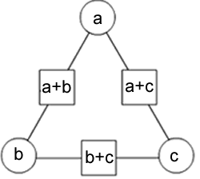
You can find the numbers being represented by a, b or c if you have numbers in the squares.
We will show this by finding b using an example found on the website:
Using the equation (b+a)+(b+c)=2b+a+c
you can take away a and c to find 2b:
(2b+a+c)−(a+c)=2b
So (b+a)+(b+c)−(a+c)=2b
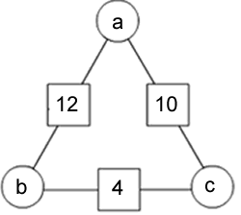
2b=12+4−10=6
b=3
This also works with negative numbers.
Robert from Leventhorpe School used a similar analysis:
To work out the formula for working out these arithmagons, we must first substitute the numbers as such:
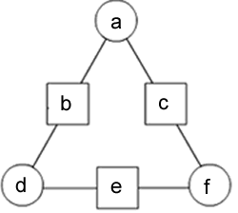
If we know bc and e, then we can say that
a+d=b,
d+f=e and
a+f=c
In the first one, b=12c=10 and e=4,
so a+d=12, d+f=4 and a+f=10
If we then add all of these together,
we get (a+d)+(d+f)+(a+f)=12+4+10
We do not need the brackets,
so we can make it a+d+d+f+a+f=26
This can be cancelled down to 2a+2d+2f=26
If we then divide everything by 2 we get a+d+f=13.
Because we know that a+d=12, f must be 1.
Since d+f=4, d must be 3.
Finally, we can say that a must be 9.
Double checking this, it works. Take a look:
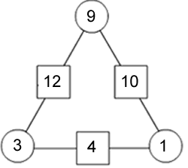
Tom from Colyton Grammar School also used some algebraic thinking to analyse the problem:
If the circles were zy and x from the top clockwise and the squares are qr and p from the left clockwise then
x+z=q,
z+y=r
and x+y=p.
q−r=x−y
so q+p−r=2x
so x=(q+p−r)2.
This means that y=(p+r−q)2
and z=(q+r−p)2, by symmetry.
Shaun from Nottingham High School came to the same conclusion:
It struck me this problem would be most easily investigated using simultaneous equations as a means of deriving a common rule for all arithmagons.
I will call the three circles of the arithmagon ad and f.
Hence, each squares can be expressed as the sum of two of the variables.
Since we have three variables, and three equations involving two of them each, we know it can be solved this way.
Some preliminary doodlings proved this to be true.
Let the squares be defined as follows:
(1) a+d=b
(2) d+f=e
(3) f+a=c
Therefore:
(4) b+f=c+d
(5) b+f=e+a
(6) e+a=c+d
From (4): f=d+c−b
Combining this result and (2):
e−d=d+c−b
2d=e−c+b
d=(b+e−c)2
And so, using this formula, the value in a circle, when the three squares in the arithmagon are known, can be found.
Of course, the variable b can be used to denote any of the three circles, and x and y the adjacent squares (does not matter which), and z the opposite.
Following these rules, the formula can also be written as:
a=(b+c−e)2
c=(c+e−b)2
I think the process I have gone through above explains why all arithmagons can be completed - they all exhibit these attributes, and so can all be solved in the same way.

