Nom : ____________________

/54

Mathématiques 20-4

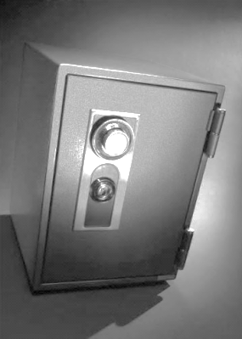

**Services financiers**

**Examen de module**

Question # 1. /25



Voir les renseignements sur les comptes de la Banque Nord-Ouest du Canada ci-dessous.

|  |  |  |  |
| --- | --- | --- | --- |
|  |  |  |  |



Question # 2. /2



Question # 3. /15





|  |
| --- |
|  |



|  |
| --- |
|  |



|  |
| --- |
|  |

Question # 4. /12





|  |
| --- |
|  |



|  |
| --- |
|  |



|  |
| --- |
|  |



|  |
| --- |
|  |



|  |
| --- |
|  |



|  |
| --- |
|  |