Intro Personal Response to Text
You have been provided with Shaun Tan’s graphic short story, “The Lost Thing”, in both text and image. The story follows a bottle collector’s quest to find a home for an unidentified lost thing. Thoughtfully read the text and study the corresponding illustrations. Once you have done this, chose one page of illustrations that you will use to support the central idea of your personal response.

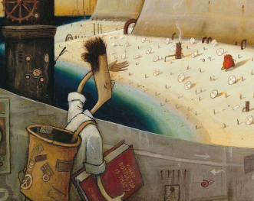

The Assignment
Late in the story, the narrator confesses the following:
Well, that’s it. That’s the story. Not especially profound, I know, but I never said it was. And don’t ask me what the moral is.
Consider the open-ended nature of the story, the text as a whole, the image of your choosing, and your central idea while constructing a personal response to the following.
What do the text and your image suggest to you about the ways in which individuals struggle to solve problems they recognize? Support your idea(s) with reference to the text and the image of your choice and to your previous knowledge and/or experience.
In your writing, you must
- use a prose form
- choose a perspective from which to write
- connect the texts provided to your own ideas and impressions
- complete the initial planning page

*This assignment will be marked out of 20 according to the 30-1 Personal Response rubric.

Initial Planning
Your initial planning will assist the marker in identifying how you intend on dealing with the texts to which you are responding. What is the connection between the text(s) and your response? What theme are you going to discuss in your response?
____________________________________________________________________________________________________________________________________________________________________________________________________________________________________________________________________________________________________________________________________________________________________________________________
How do you intend of connecting the text to the theme?
____________________________________________________________________________________________________________________________________________________________________________________________________________________________________________________________________________________________________________________________________________________________________________________________
What three details from your image will you use to support your response?
____________________________________________________________________________________________________________________________________________________________________________________________________________________________________________________________________________________________________________________________________________________________________________________________
State your choice of perspective and prose form.
Perspective - Personal creative analytical (Do not use a poetic form)
Prose form __________________________________________________________________

