Liste des Gizmos
Math 10-20-30

Square roots

Ordering and Approximating Square Roots

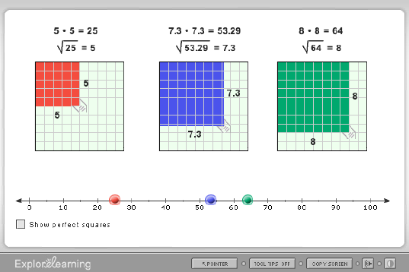

Function Involving Square Roots

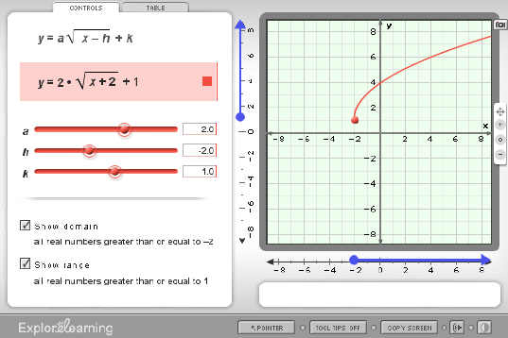

Roots of a Quadratic

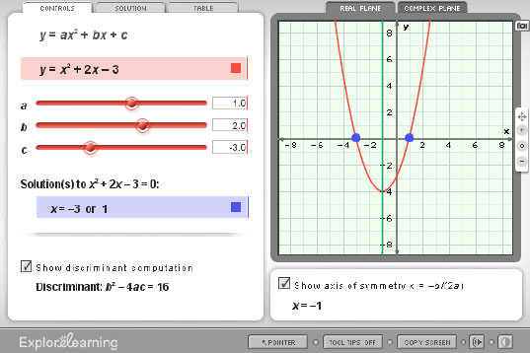

Exponents and Power Rules

Permutations and Combinations
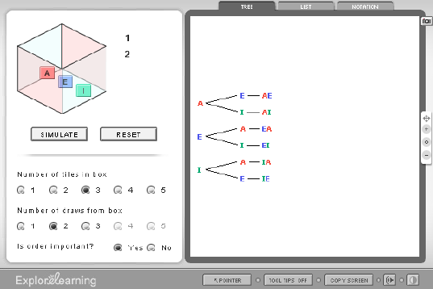
Solving Linear Systems by Graphing
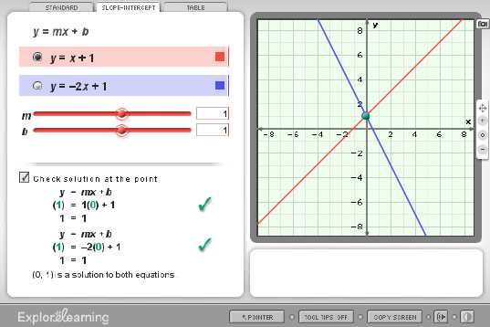

Linear Inequalities in Two Variables – Activity A
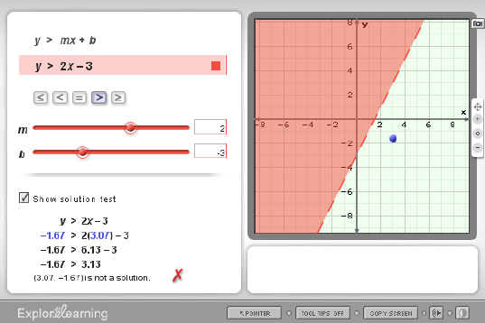
Sine, Cosine and Tangent
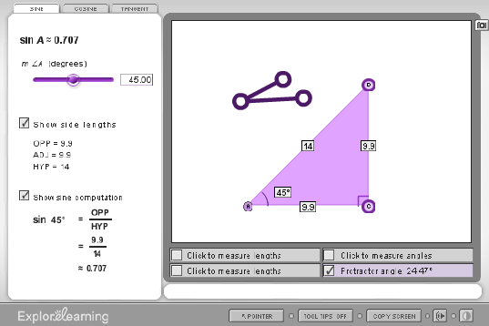

Cosine Function
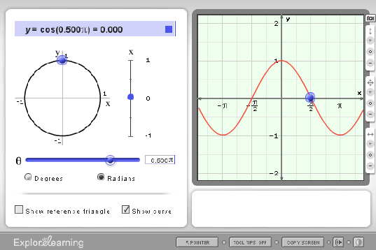
Tangent Function
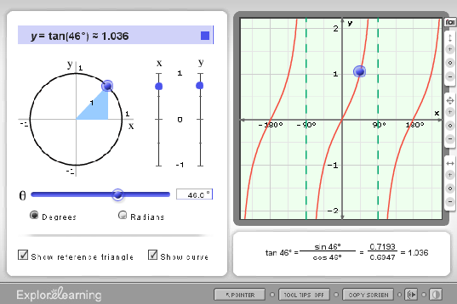

Absolute Value with Linear Functions – Activity B
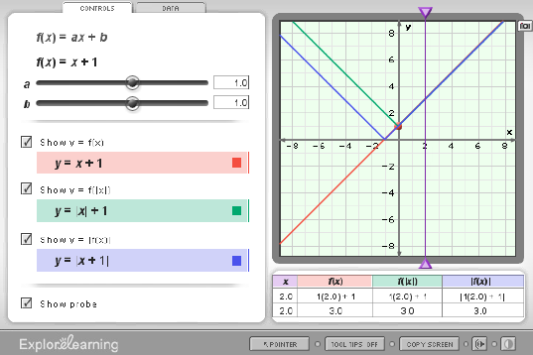
Quadratics in Polynomial Form – Activity A
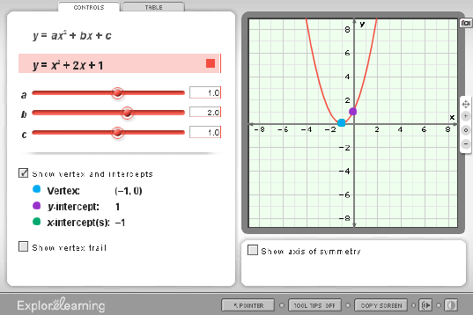

Operations with Radical Expressions
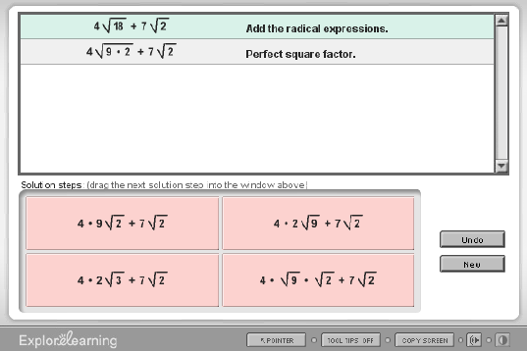
Arithmetic Sequences
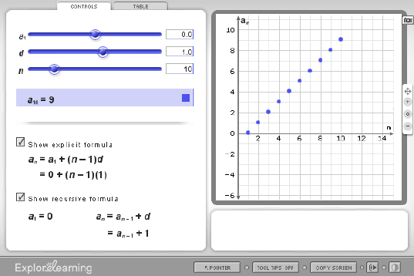

Geometric Sequences
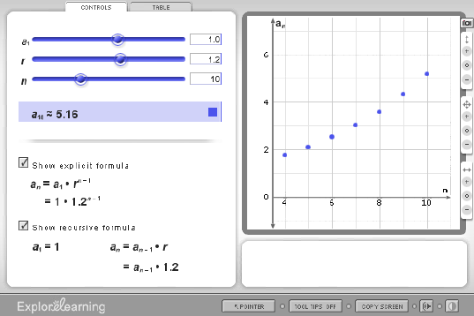
Logarithmic Functions – Activity A
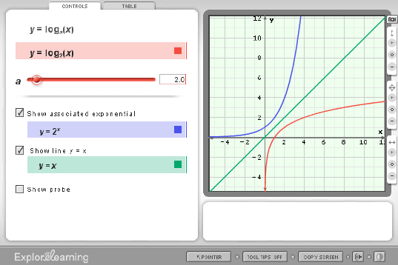

Exponential Functions – Activity A
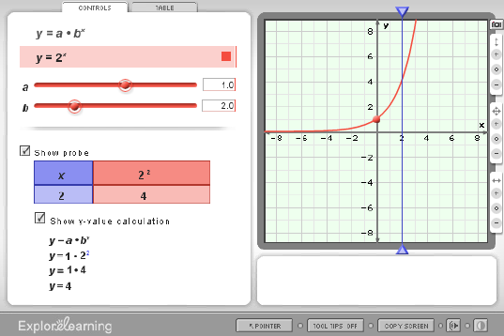
Unit Circle

Pyramids and Cones
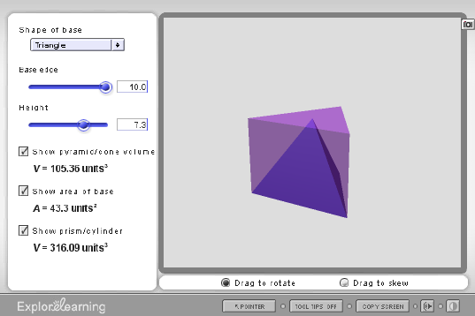
Modeling the Factorization of x² + bx + c
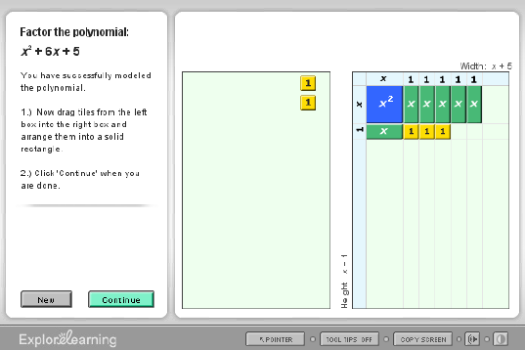

Bisectors in Triangles
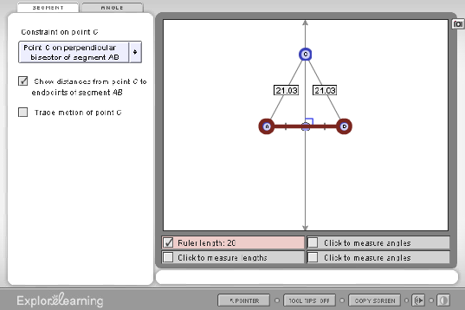
Binomial probabilities
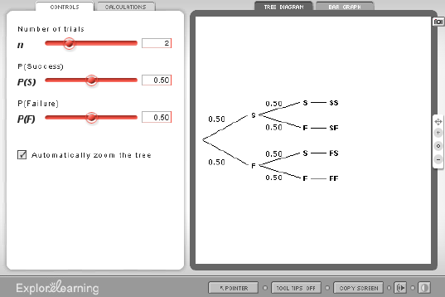

Probability Simulations
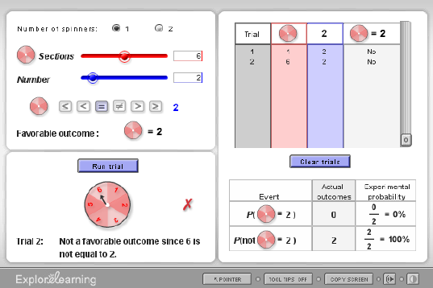

Liste des Gizmos
Math 10-20-30

Mesures
- Perimeter, area and volume
- Scale

Statistiques et probabilité
- Analyzing and displaying data
- Inferences and predictions
- Probability

Le sens du nombre et opérations
- Integers, decimals, and square roots
- Fractions and factors
- Ratios, proportions, and percents
- Exponents and powers
- Permutations and combinations
- Complex numbers
- Matrices
Algèbre
- Solving linear equations
- Graphing linear equations and functions
- Linear inequalities
- Systems of linear equations and inequalities
- Quadratic functions and inequalities
- Absolute value
- Radical functions and rational exponents
- Exponential and logarithmic functions
- Rational functions
- Polynomials and factoring
- Transformations
- Conics
- Sequences and series
- Trigonometric functions
Géométrie
- Lines and angles
- Reasoning and proof
- Area
- Quadrilaterals and other polygons
- Triangles
- Similarity and transformations
- Right triangle trigonometry
- Circles
- Three-dimensional figures

